MY Beauty for Your Ashes & Our Relationship
December 30, 2016

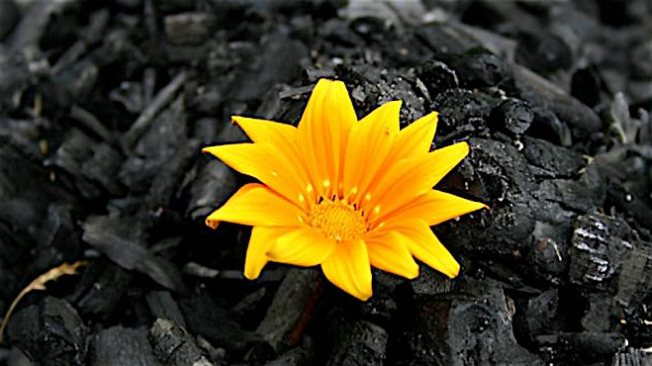
May the new life Our Lord is offering us bring us the fullness of union with Him and fruit for His Kingdom, Heartdwellers.

What a joy it has been to be dancing with Jesus again and resting in His loving arms. Truly He is beginning the new year by drawing us into a deeper union with Him.

Jesus began, “My people, as you draw closer to Me, letting your guard down, truly letting go of everything - every stress, every fear and apprehension, every guilt and failure. As you do these things, you and I will become One, more and more.

"What a beautiful exchange I am giving to you. Your sins, your fears, your failures in exchange for My Love. The only way you will succeed in your relationship with Me and make it to the high calling is through complete trust.

"This is the High Calling: complete release and trust that everything I think of you, everything I want for you, everything My Heart longs to give you is good beyond measure and will bring you closer, deeper and more intimately tied to Me. So much so, that grace and mercy will flow directly through your heart to the lonely, hurt and disenfranchised wandering sheep with no valid shepherd.

"So much has been neglected in feeding you, My People. The most key and central issue is not your perfect, sinless conduct, although there is great merit in that. No, it is your love for Me and your love for your neighbor.

"Satan knows this well and so his tactic is to cause alienation between you and I, so that we will not function as One and you will not heal the wounded.

"Yes, this relationship is risky. Yes, you can make mistakes. But more than your mistakes is My faithfulness to lead and guide and equip you to be grafted solidly in My heart that your fruit may be My fruit and My fruit may be your fruit. That is the plan - that I flow through you so perfectly that one loses track of you ministering, but feels My presence very clearly and securely.

"Yes, that is a tall order, but it is so necessary! This is how we will minister to the world. And only through your complete letting go of every single fear and reticence will you accomplish this. You must convince yourself that there is nothing to be ashamed of in My presence. Nothing I cannot forgive, nothing you have to do first. It is 'come as you are' and let Me graft you into the vine so perfectly that hardly will others be able to tell where you let off and I begin.

"In the process of this, your sins and shortcomings will come to the surface and you'll be given the chance to ask for My forgiveness and feel the sorrow that you caused Me. But it will quickly pass away, and the Joy of being with Me will overcome you.

"Beloved, can you trust Me?

“Can you?

“Can you?

“Please think long and hard about this. When you come to Me, I want all the walls and defenses down and only an open heart ready to receive every grace without question into your hearts and being. This is what I need from you.

"But first, you must let go of ALL your fears. And I do mean ALL. Every single one is coming from Satan, who does not want you to thrive in Me. Rather his goal is alienation. You must be more clever than he is. You must be so clever that there is no vestige of his thoughts and words when you come to Me. Rather your heart and mind are totally transformed by My goodness.

“I need you, My Bride, My Children. I need forward-thinking souls who can and will conquer their fears regarding Me. I have seen you at your best. I have seen you at your worst. Give Me your ashes and I will clothe you in My beauty.

“Is this so hard? Can you? Will you?

“I am extending the grace to you right now in your hearing ears. Receive this grace of trust and transparency before Me. Receive it."

And I just wanted to make a short announcement and let you all know that the portrait is finished and there's going to be a copy up on our website. It's not the high-resolution copy, because the photographer is on vacation. And that will be remedied next week, by about the 4th of January. And that really large file will be available to you. But in the meantime, you're welcome to download this image and do anything you want with it, except it's not for sale. Please don't do that!

And also I want to let you know that the book Rhema is available now on Amazon. So, I've been using it and wow! It's really, really helped me, really takes me back into some of the teachings the Lord has given us, but are so on target for the different things that we face every day. Carol Jennings has done the editing. She's gone through all the teachings and pulled out the most relevant ones. And she's done a magnificent job of making this book really instructive and really helpful. We have Carol to thank for that and the Lord working through her.

I'd be happy to give this book away, but right now I know that they're going to cause me to charge for it, and I can't get around that in any way, shape or form. So, paying for the book for free wouldn't do me any good - they'd still make me charge for it.

So, it is available and the distribution is wonderful, because it can go around the world.

Thank you for being a part of our lives. We lift you up in prayer every day, in prayer and blessing and protection. The Lord bless you, dear Heartdwellers.

